Source 1
(Political poster drawn by Russian cartoonist Viktor Deni, a Communist political propagandist, in 1921.)
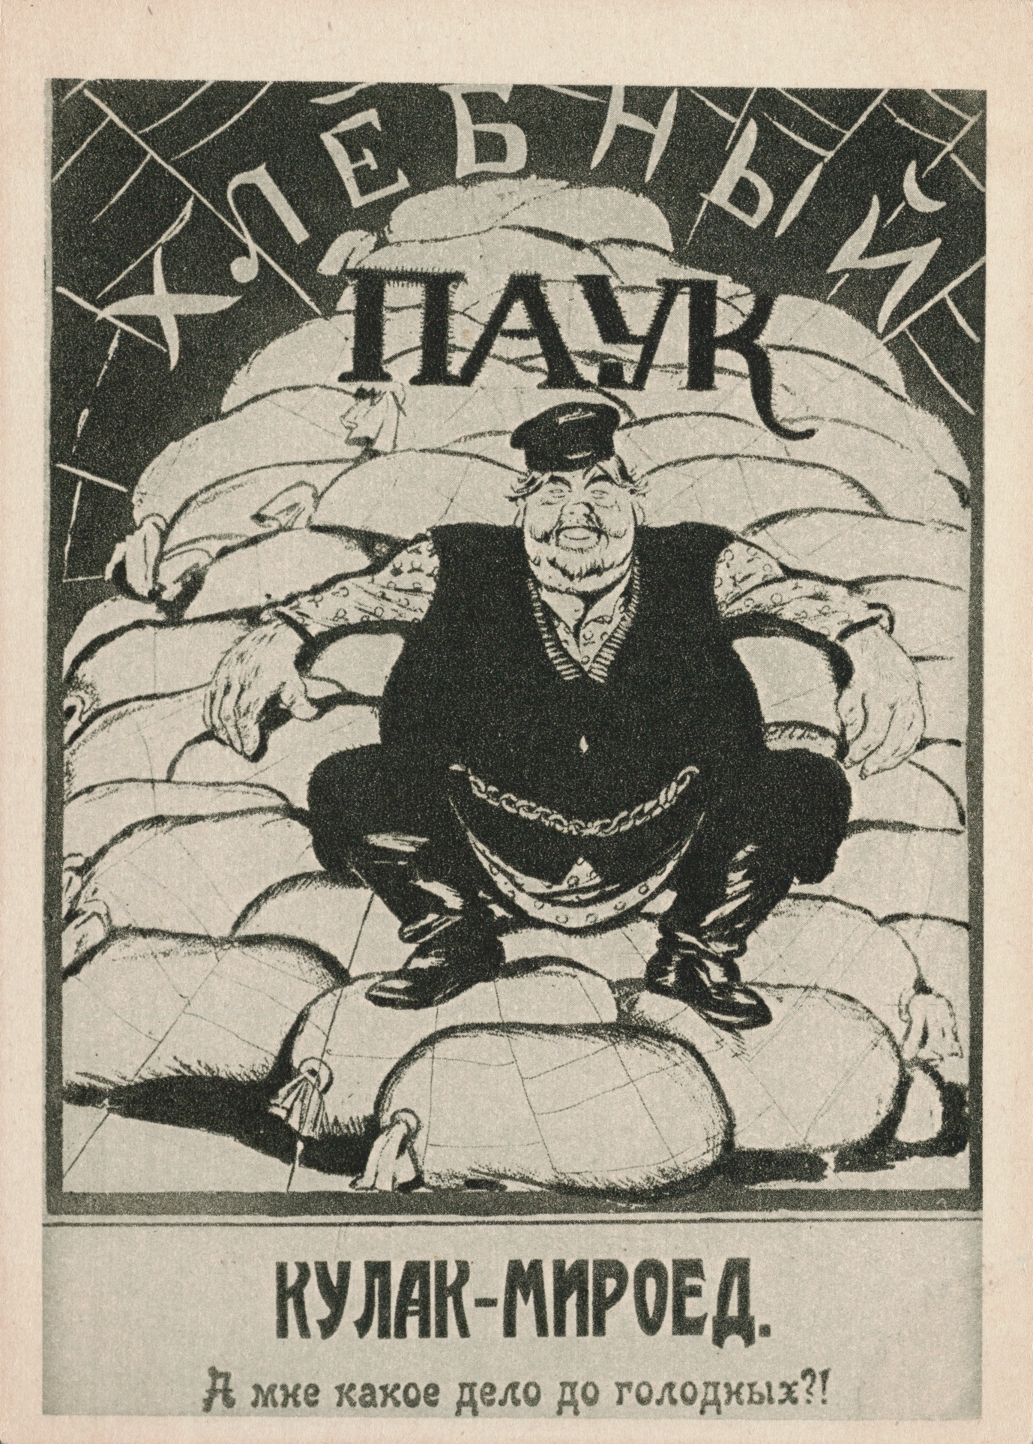
“Bread power. Kulak-bloodsucker: What do I care about the hungry?!”

Source 2

Source 3
(Extracts from a speech by Stalin to Industrial Managers in February 1931 about the need for the Five-Year Plan.)

It is sometimes asked whether it is not possible to slow down the tempo somewhat, to put a check on the movement. No, comrades, it is not possible! The tempo must not be reduced! On the contrary, we must increase it as much as is within our powers and possibilities. This is dictated to us by our obligations to the workers and peasants of the USSR …

To slacken the tempo would mean falling behind. And those who fall behind get beaten. But we do not want to be beaten. No, we refuse to be beaten! One feature of the history of old Russia was the continual beatings she suffered because of her backwardness …

If you do not want this you must put an end to its backwardness in the shortest possible time … That is why Lenin said on the eve of the October Revolution: ‘Either perish, or overtake and outstrip the advanced capitalist countries.’

We are fifty or a hundred years behind the advanced countries. We must make good this distance in ten years. Either we do it, or we shall be crushed.

Source 4
(Extract from a modern history text published in 2000, addressing why the Five-Year Plans were necessary.)

Fear of invasion gave added weight to the economic reasons used to justify the Five-Year Plans. Under the NEP industrial production, although improving, remained disappointing to many in the Communist Party. By 1926 pre-war levels of production had been reached in many sectors but production was nowhere near what it could have been.

The disruption of the First World War and the civil war had damaged Russia’s industrial infrastructure, and essential services such as distribution remained haphazard. Soviet production figures were still far below the modern industrial economies of Western Europe. State control under the Five-Year Plan would enable the government to direct the economy and ensure the adequate production and distribution of essential materials including the food needed to support industrial and urban growth. With government direction and control the economic resources of the Soviet Union could be maximised. Since the communist takeover in 1917, trade with the rest of the world had been severely reduced. The Soviet Union would have to rely on its own resources. State control would ensure that the full potential of those resources would be realised, so as to bring about rapid industrialisation.

Set 5: Elective 2: Australia’s engagement with Asia
Source 1
(Extract from a speech by Prime Minister Menzies in the Federal House of Representatives in 1964.)

The range of likely military situations Australia must be prepared to face has increased as a result in the growth of communist influence and armed activity in Laos and South Vietnam. If these countries collapsed, there would be a grave threat to Thailand and the whole of South-East Asia would be put at risk. The effectiveness of the South-East Asia Treaty Organisation as a guarantee of mutual security would be seriously jeopardised. Australia is in SEATO, not only because of goodwill towards the nations concerned and a desire to help protect them against communist aggression, but also because the further communist powers are kept away from Australia, the greater the feeling of security. Australia is with Malaysia not only because it is a well-governed and friendly Commonwealth country, but also because it is willing to resist the communists. It is also important to Australia that Indonesia should not become communist, but retain its independence under a government serving only the good of the Indonesian people.

Source 2
(Cartoon by Peter Nicholson, published in The Australian in 1979 and showing the Australian Foreign Minister, Andrew Peacock, and Indonesian President Suharto. Suharto is sweeping skeletons into a rubbish bin.)
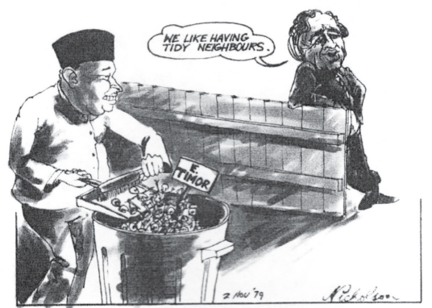
‘We like having tidy neighbours’, 2 November 1979.

Source 3
(Extract from a history text written by an Australian political commentator in 2009.)

... Keating felt that the end of the Cold War created a new opportunity for Australia. He pursued a grand strategy based on two ideas—to entrench Australia in the rising economic dominance of the Asia – Pacific and to integrate the US Alliance into Australia’s Asian future. He pursued them with passion and with remarkable consequences …

Keating’s grand strategy did not deliver its full potential. APEC¹ is a vital instrument but will never become a central mechanism for America’s role in Asia … Keating’s vision was often egocentric. Yet he got results and created new Asia–Pacific mechanisms that served Australia’s interests. He led from the front by refusing to tolerate second-best results. He envisaged the region not only as it existed but as it should exist. Above all, he popularised the idea of a grand Australian strategy—seeking to integrate ties with the United States and East Asia. His ‘engagement with Asia’ is a national project that will have no end.

¹ APEC – Asia-Pacific Economic Cooperation

Source 4

